CODING AND SOLUTIONING

|  |  |
| --- | --- |
| **DATE** | 24 NOVEMBER 2022 |
| **TEAM ID** | PNT2022TMID46309 |
| **PROJECT NAME** | IoT BASED SMART CROP PROTECTION SYSTEM FOR AGRICULTURE |
| **PROJECT DOMAIN** | INTERNET OF THINGS |

* 1. : FEATURE 1

# A Web Application is built which consists of,

* + - **Graphical representation of Humidity, Temperature and Soil Moisture**

# Motor ON and Motor OFF

**Step 1**: Generate random values of Humidity, Temperature, Soil Moisture are generated from events in the Watson IOT platform. These sensor values are generated using random functions from the events that is used in the device which was created.

|  |  |
| --- | --- |
| PAYLOADS | SENSORS |
| Temp | Temperature |
| Hum | Humidity |
| Moist | Moisture |

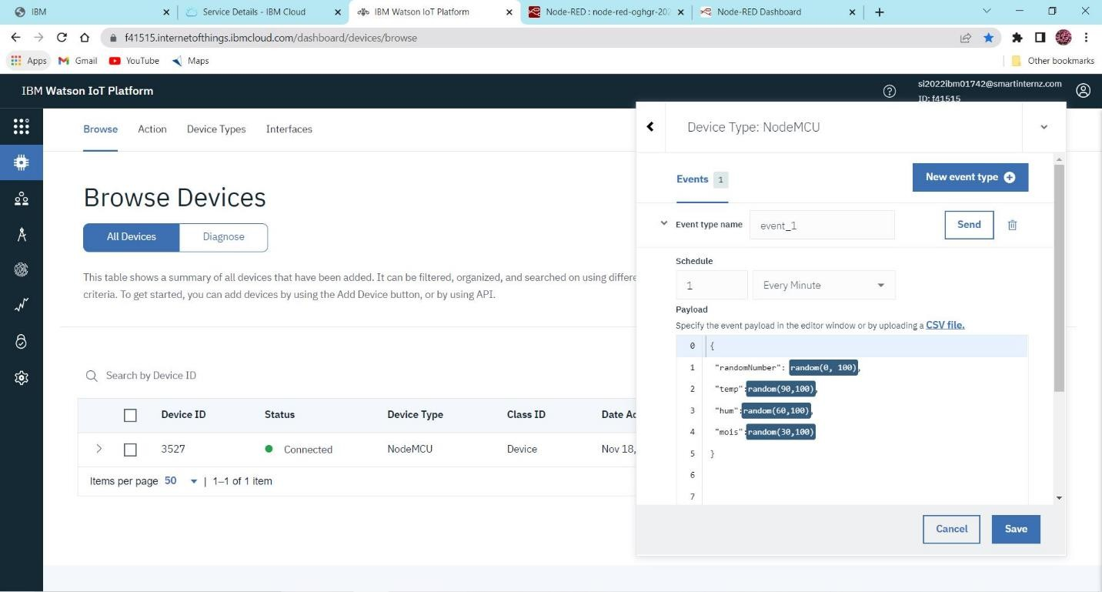

**Step 2:** The values are generated for every minute as payload from events in the form of **json** format in the recent events of the device created in Watson Platform

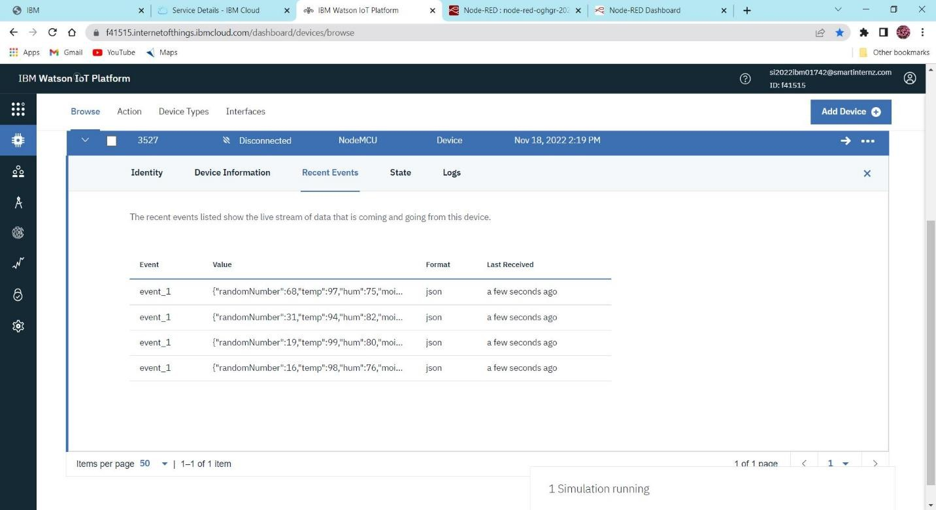

**Step 3:** Node-RED is an editor used to create the flow between the nodes and has to be deployed once the flow has been made. Once deployment is done sensor values can be viewed in detail

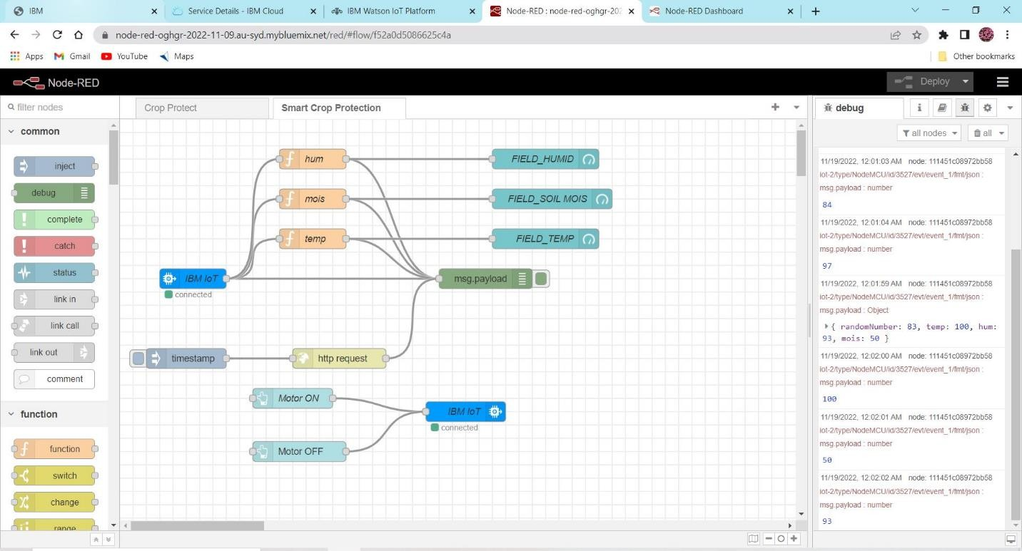

**Step 4:** The **Smart Crop** dashboard is viewed once the deployment is completed where we can able to view,

1. Moisture in the form of gauge
2. Temperature and Humidity in the form of gauge
3. MOTOR ON and MOTOR OFF buttons

# Details:

1. Dashboard is named as Smart Crop
2. Section is named as Field

In the section of Field, the sensors values are represented and motor control buttons are also given.

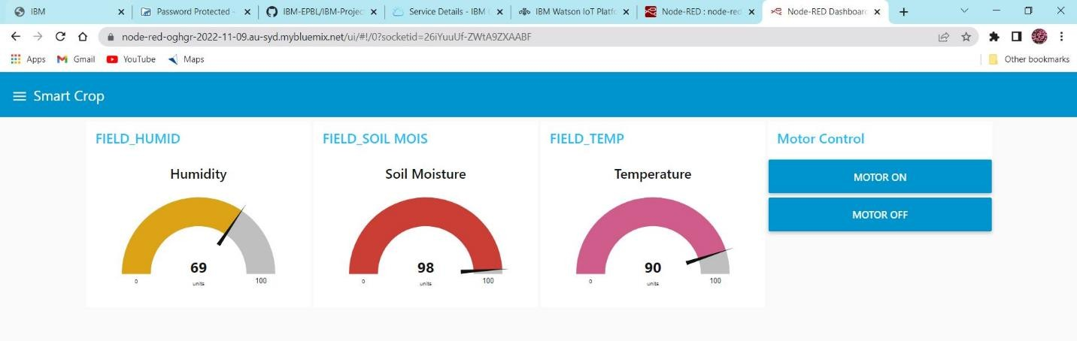

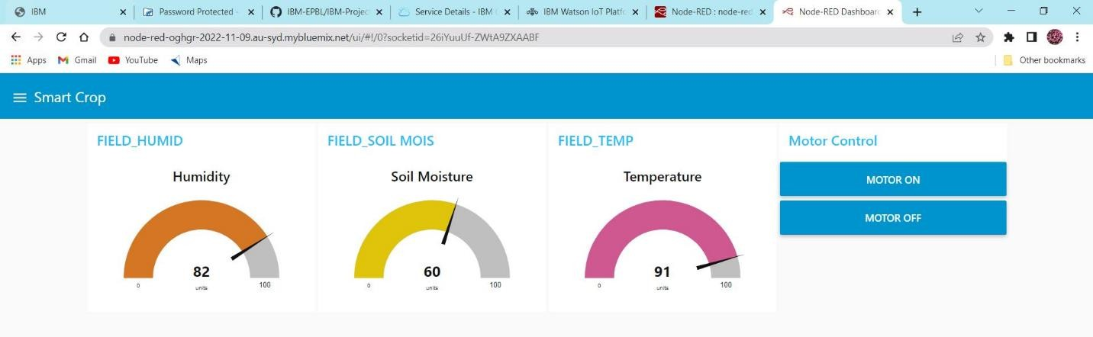

**Step 5:** When the **Motor ON** button is clicked the we receive the output as **“motoron”** and **Motor OFF** button is clicked we receive the output as **“motoroff”**. And these outputs are received in the debug section of the editor

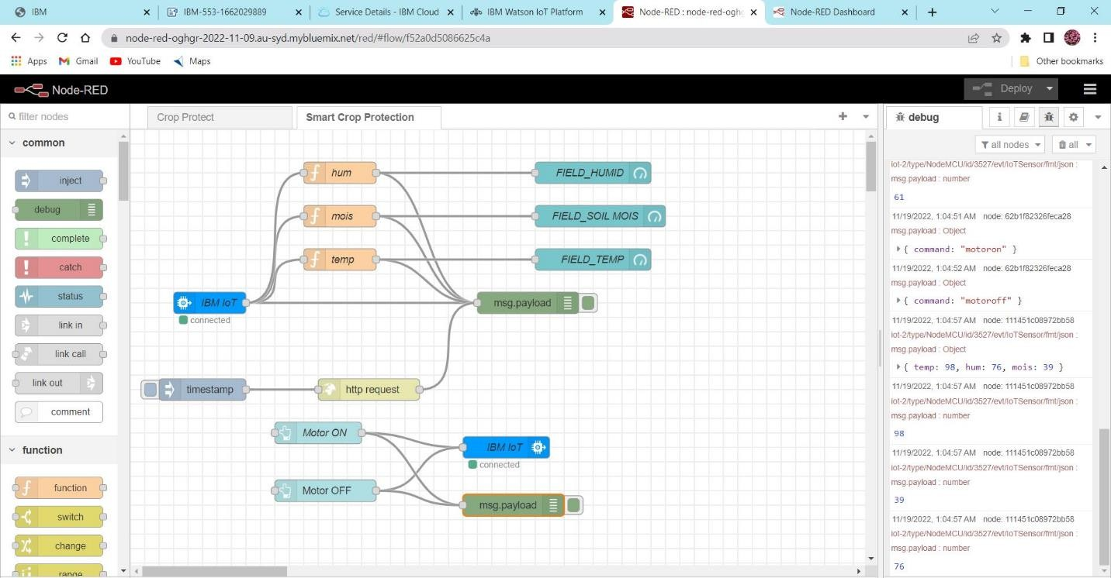

**Step 6:** The output is also received in the **python code editor** when the buttons are clicked in the dashboard and random values are also generated. Device id is used to connect to IBM Watson.

